CLASS EXERCISE 3

Aggregate/Group Functions, Set Operations, Group by…Having Clause

Aggregate Functions
- Count the total number of employees.
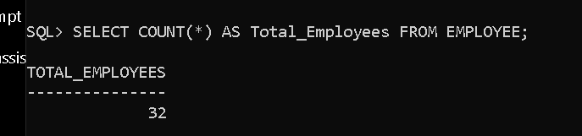
- Count the total number of projects.
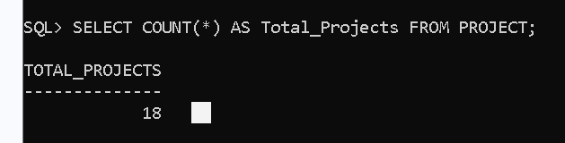
- Count the total number of employee-project assignments.
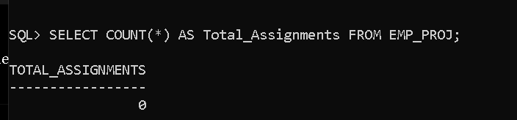

- Find the average salary of employees.
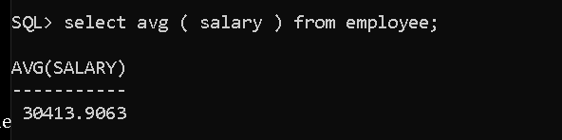

- Display the maximum and minimum salary of employees.
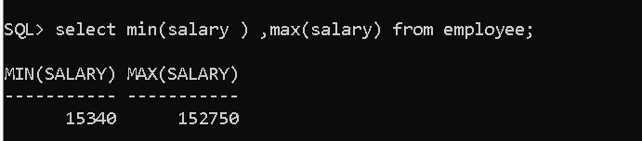
- Rename the columns as Max_Salary and Min_Salary
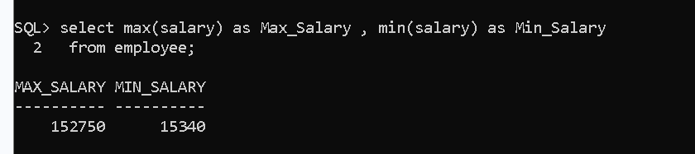

- Find the total salary paid to all employees.
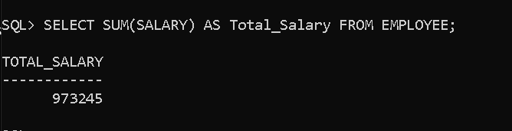
- Display the average bonus received by employees.
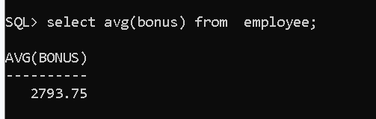

- Find the total commission paid to employees.
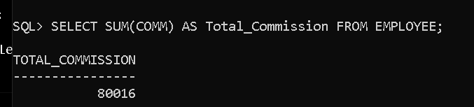
- Count the number of employees whose salary is greater than 30,000.

- Count the number of employees belonging to department D11.
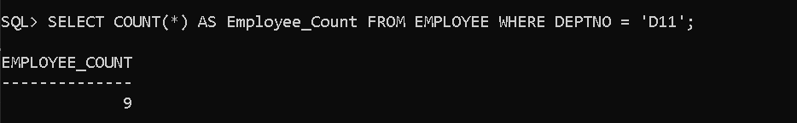

- Display the highest bonus received by an employee.
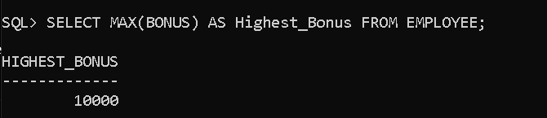

- Display the lowest commission received by an employee.
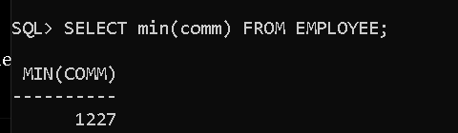
- Find the average salary of female employees.
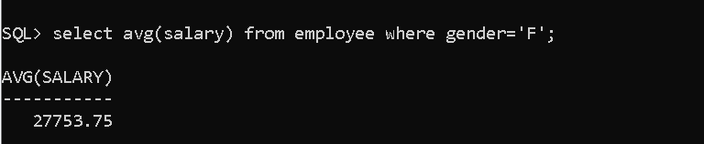

- Count the number of employees working as MANAGER.
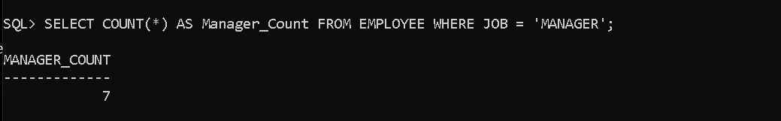
- Display the earliest project start date.
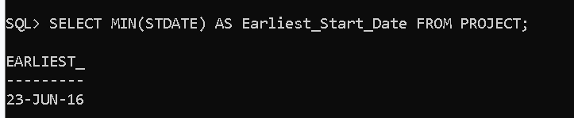

- Display the latest project end date.
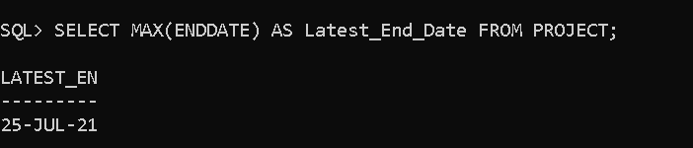
- Find the total salary, total bonus and total commission paid to employees.
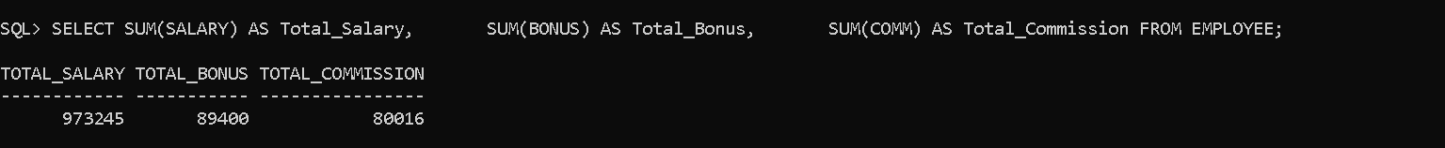

- Count the number of employees hired after 01-JAN-2018.
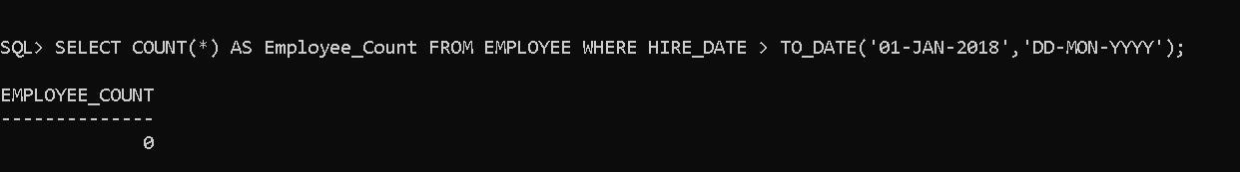

- Find the average salary of employees hired after 01-JAN-2015.
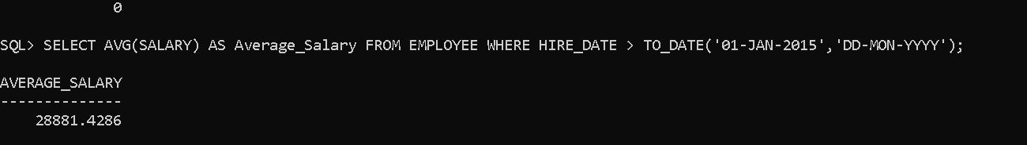
- Count the number of distinct departments in the Employee table.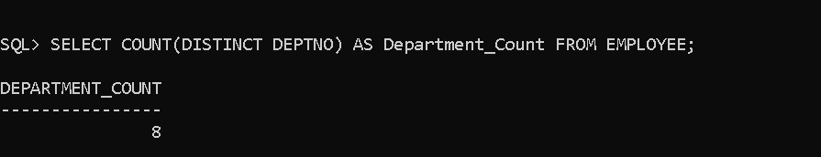

Set Operations
- Retrieve the names of all employees from both Employee and EXTRA_WORK_EMP tables without duplicate rows.
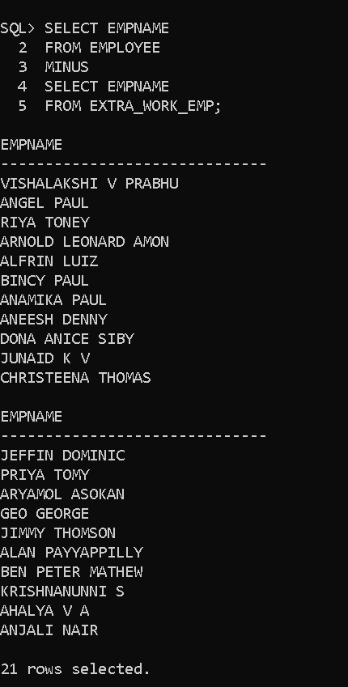

- Retrieve all employee names from both tables including duplicate rows.

SQL> SELECT EMPNAME FROM EMPLOYEE UNION ALL SELECT EMPNAME FROM EXTRA_WORK_EMP;

EMPNAME
------------------------------
MELLOW REEBA THOMAS
JOHN VARGHESE
ASHREENA HASSAN
VISHAK VIJAYAKUMAR
CORRINE ELIZABETH RODRIGUES
MERLIN M.D
MARIA JOHN
VISHALAKSHI V PRABHU
ANGEL PAUL
RIYA TONEY
ARNOLD LEONARD AMON

EMPNAME
------------------------------
PHILIP VINCENT
SHILVY K K
ALFRIN LUIZ
OSHINA ANTONY
BINCY PAUL
ANAMIKA PAUL
ANEESH DENNY
DONA ANICE SIBY
JUNAID K V
CHRISTEENA THOMAS
JEFFIN DOMINIC

EMPNAME
------------------------------
JEWEL BIJOY
PRIYA TOMY
ARYAMOL ASOKAN
GEO GEORGE
JIMMY THOMSON
ALAN PAYYAPPILLY
BEN PETER MATHEW
KRISHNANUNNI S
AHALYA V A
ANJALI NAIR
SNEHA PAUL

EMPNAME
------------------------------
ARNOLD LEONARD AMON
PHILIP VINCENT
SHILVY K K
ALFRIN LUIZ
ARUN KUMAR

38 rows selected.

- Retrieve the employee numbers and names that are present in both tables.
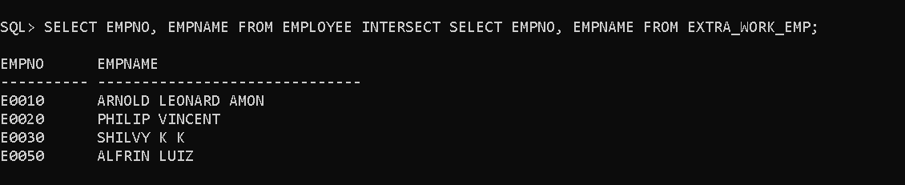

- Retrieve the names of employees who are in the Employee table but not in the EXTRA_WORK_EMP table.

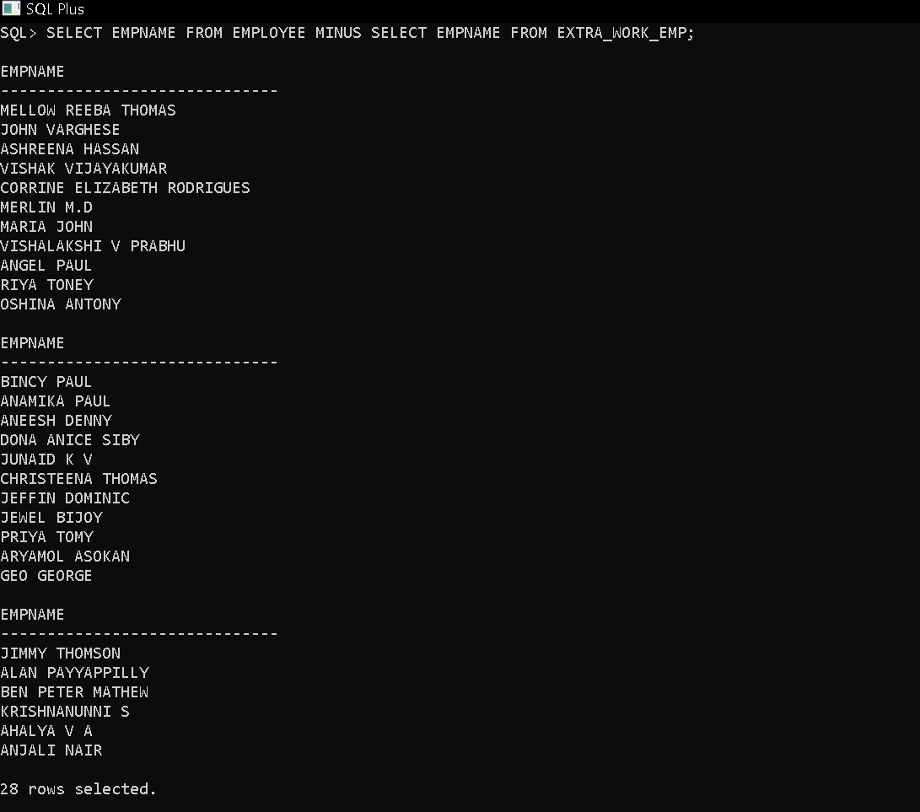
- Retrieve the names of employees who are in the EXTRA_WORK_EMP table but not in the Employee table.
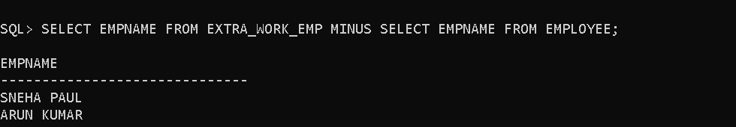
- Retrieve the department numbers from both tables without duplicate rows.
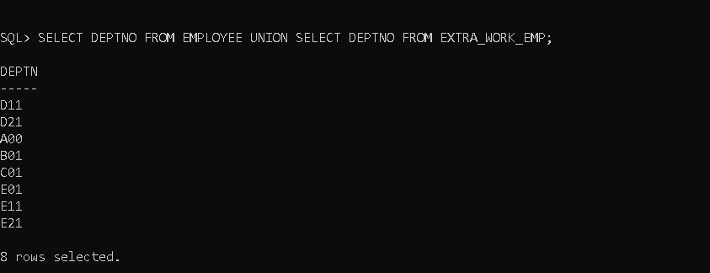

- Retrieve the department numbers common to both tables.
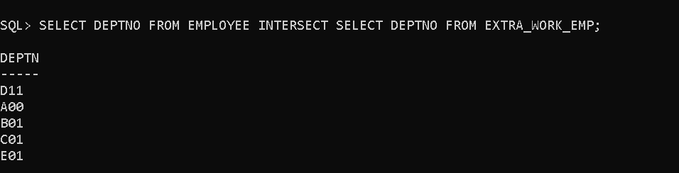

- Retrieve the department numbers present in the Employee table but not in the EXTRA_WORK_EMP table.
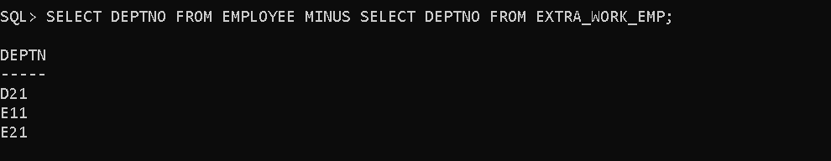

- Retrieve the employee numbers from both tables including duplicate rows.

SQL> SELECT EMPNO FROM EMPLOYEE UNION ALL SELECT EMPNO FROM EXTRA_WORK_EMP;

EMPNO
----------
E0010
E0020
E0030
E0050
E0060
E0070
E0090
E0100
E0110
E0120
E0130

EMPNO
----------
E0140
E0150
E0160
E0170
E0180
E0190
E0200
E0210
E0220
E0230
E0240

EMPNO
----------
E0250
E0260
E0270
E0280
E0290
E0300
E0310
E0320
E0330
E0340
E9002

EMPNO
----------
E0010
E0020
E0030
E0050
E9001

38 rows selected.

- Retrieve the employee numbers that exist only in the Employee table.
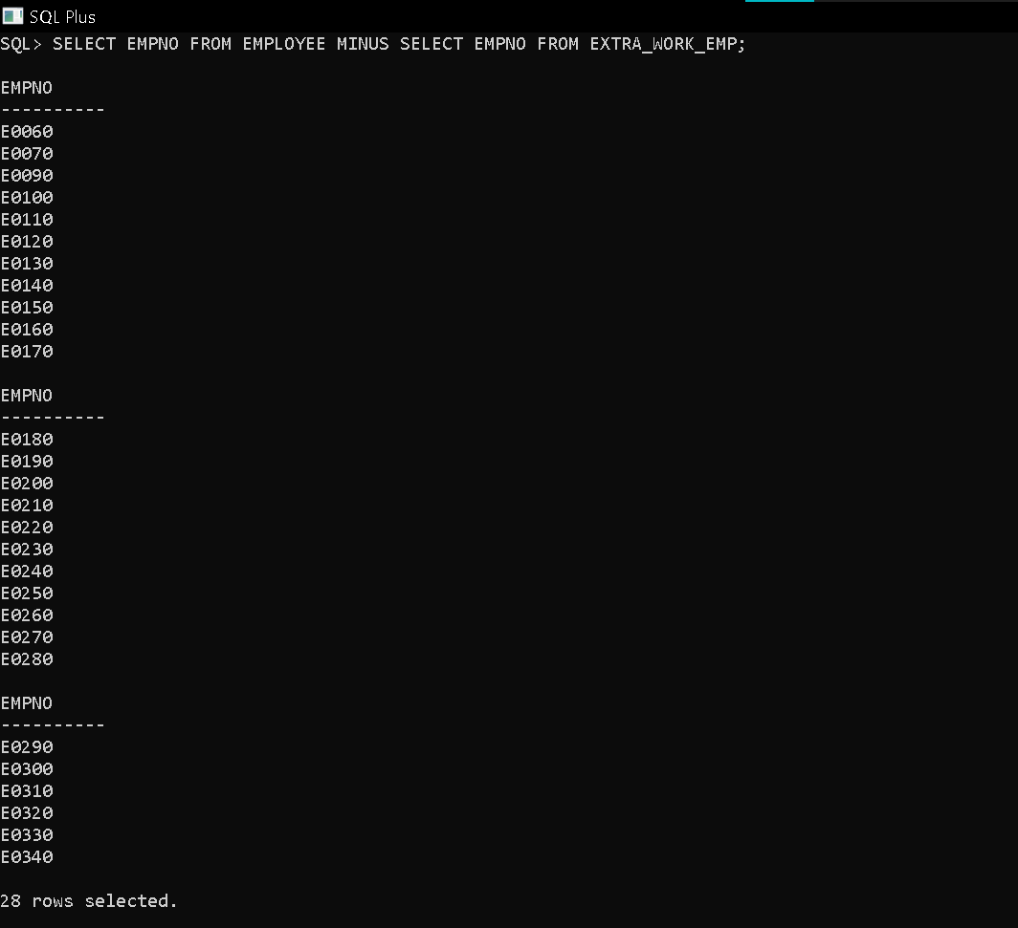

GROUP BY and HAVING Clause

- Display the department number and total salary of employees in each department.
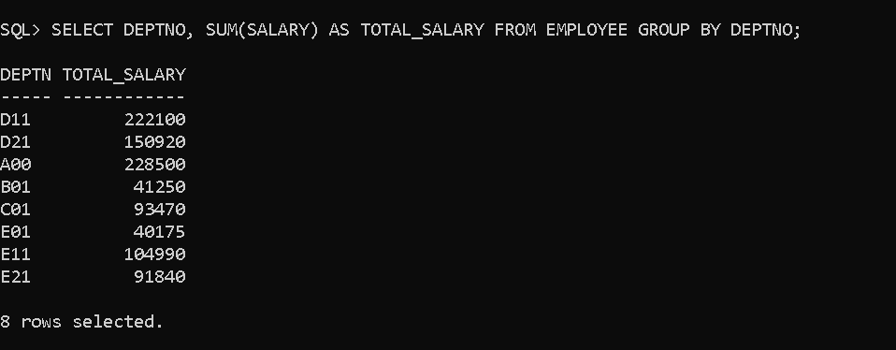

- Display the department number and average salary.
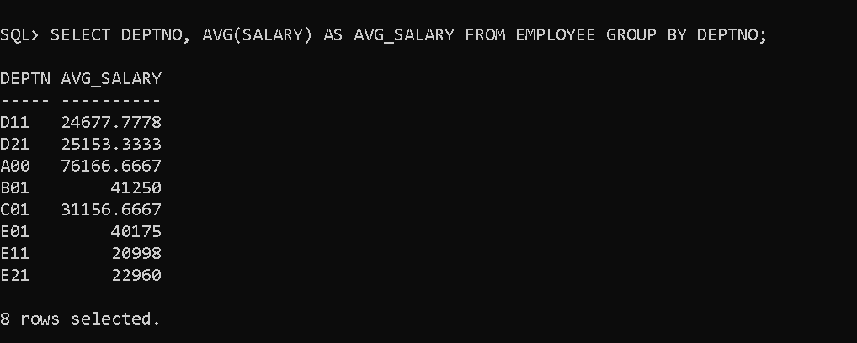

- Display the department number and number of employees.
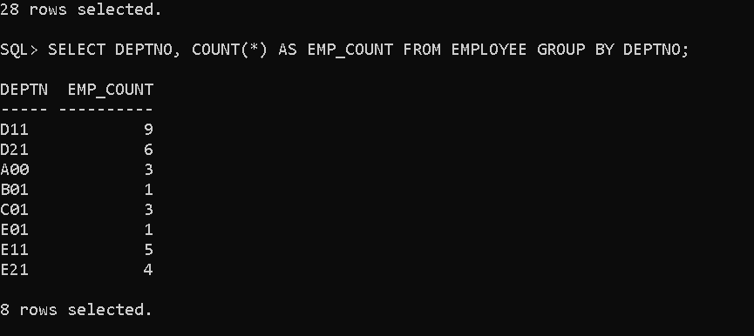
- Display each job and the number of employees.
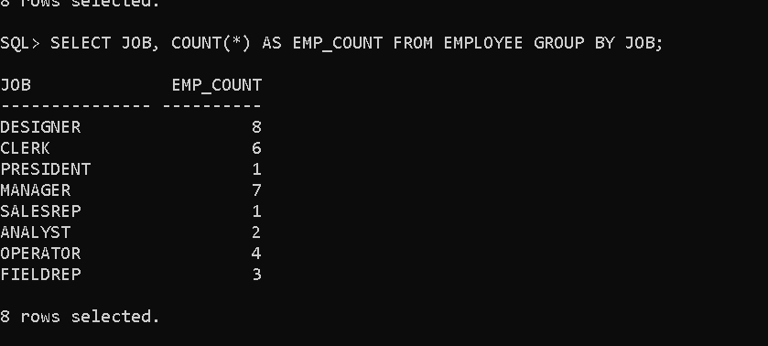

- Display each gender and the average salary.
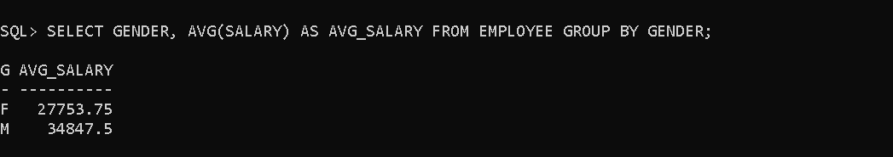
- Display each education level and the number of employees.
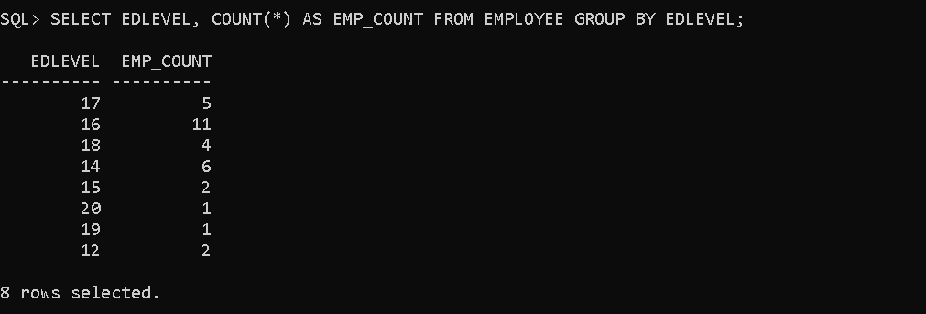

- Display each department and the total bonus paid
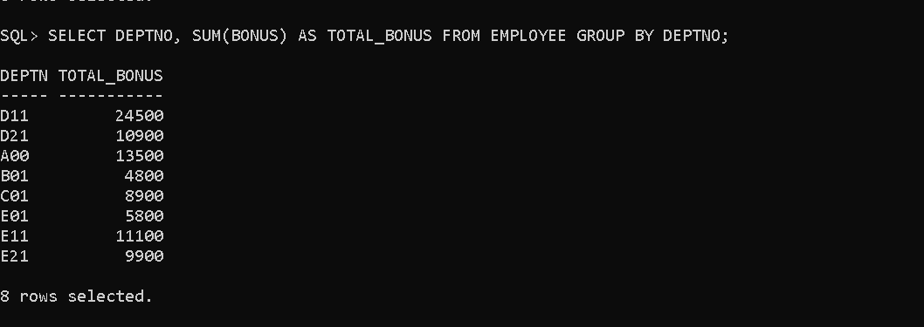

- Display each responsible employee and the number of projects handled.

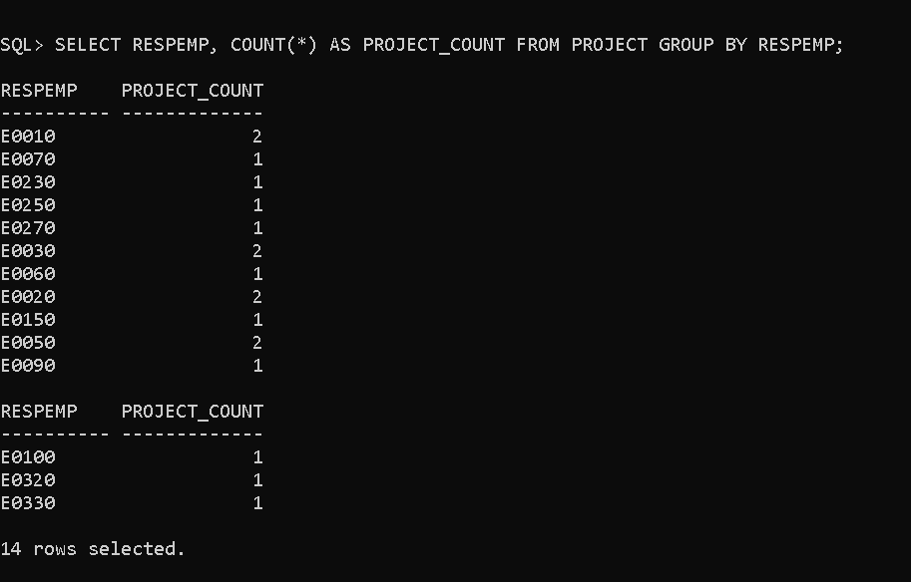
- Display each department and the number of projects.
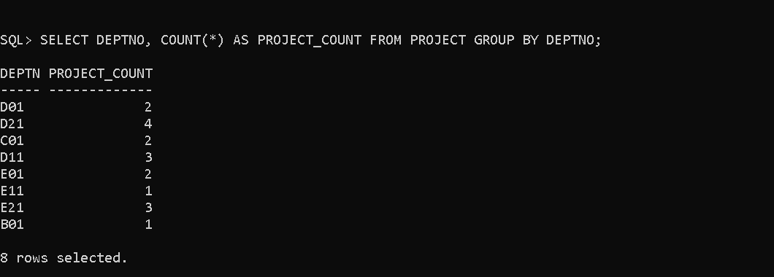

- Display each project number and the number of employees assigned.


- Display departments having more than 3 employees.
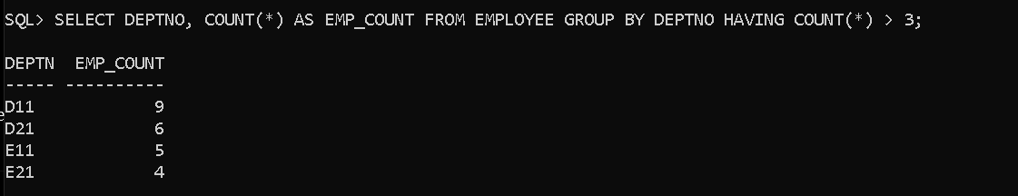

- Display departments whose average salary is greater than 40,000.
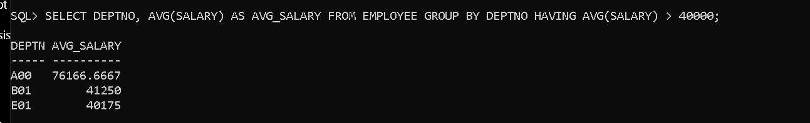

- Display departments whose total salary exceeds 2,00,000.
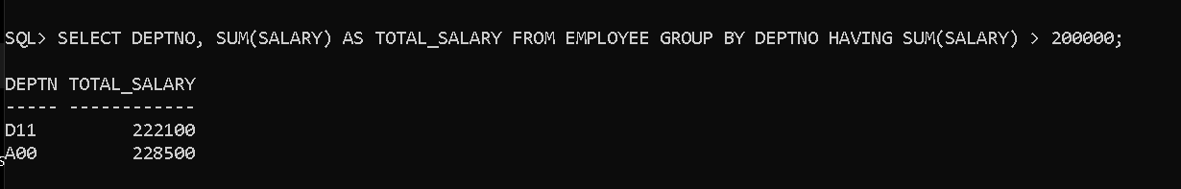
- Display jobs having more than 2 employees.
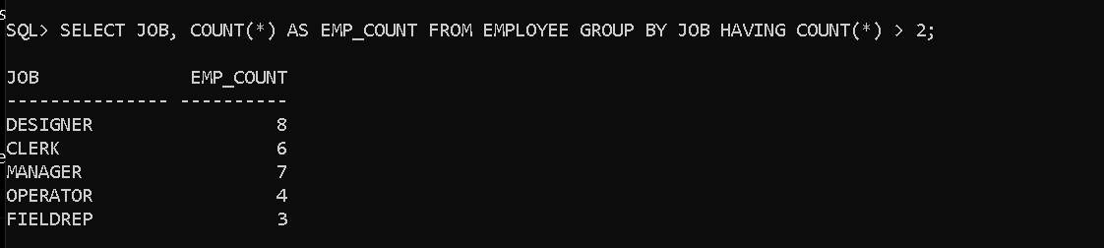

- Display education levels having at least 5 employees.
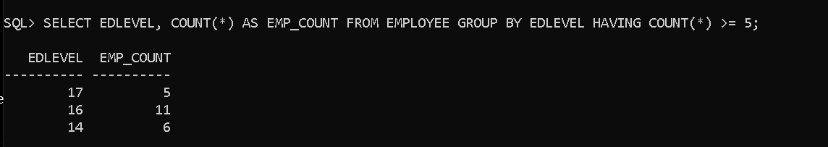

- Display departments whose maximum salary exceeds 60,000.
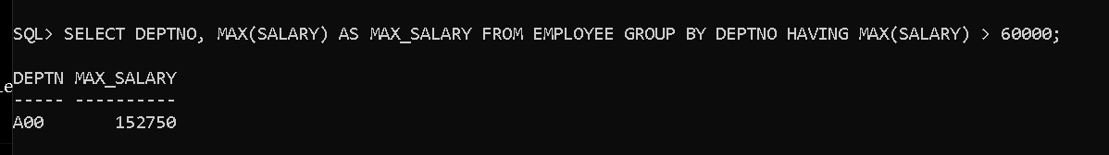

- Display departments whose minimum salary is greater than 25,000.
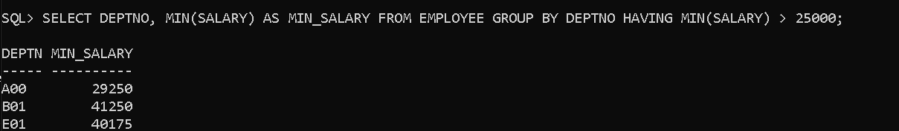

- Display departments where the average bonus is greater than 1,000.
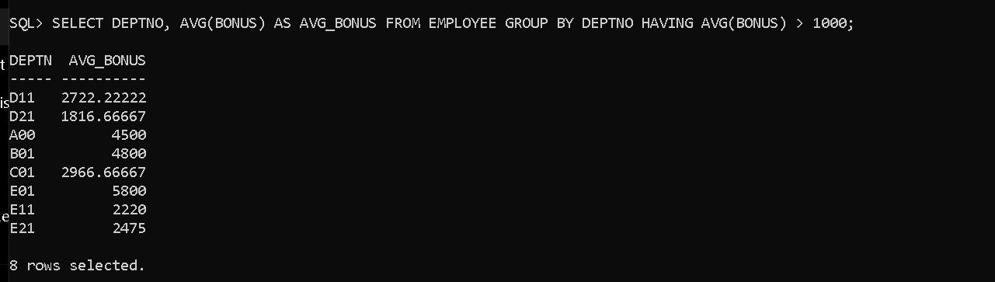

- Display departments having at least two female employees.
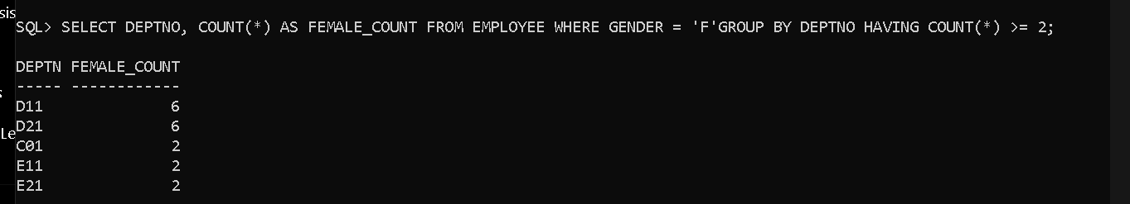
- Display jobs whose average salary is greater than 35,000.
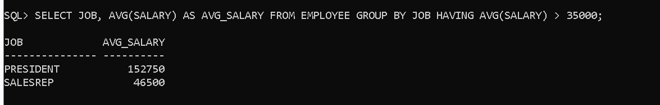

- Display departments having more than 2 projects.
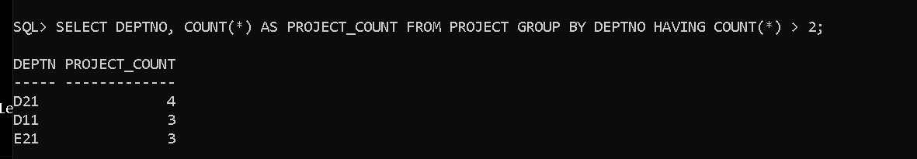
- Display responsible employees handling more than one project.
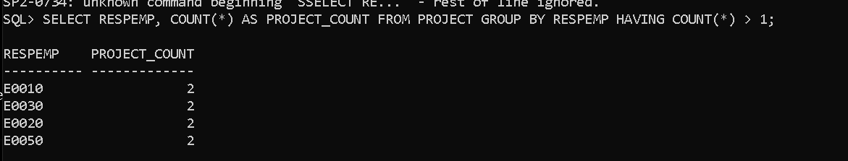

- Display projects having more than 3 employees assigned
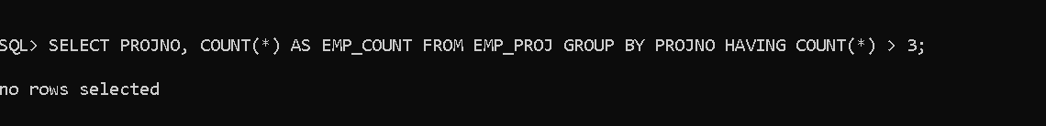
- Display employees working on more than one project.

- Display the department number, employee count, total salary and average salary for departments having more than 3 employees.
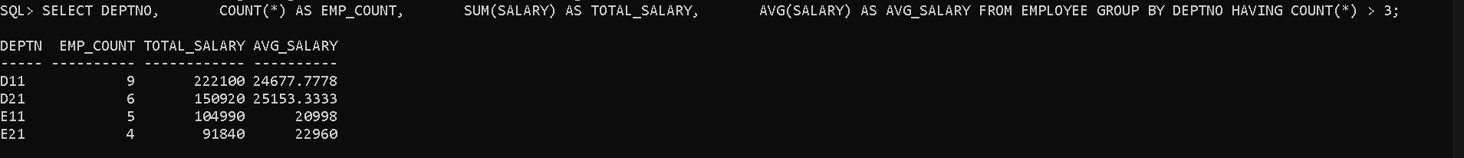

- Display the job, employee count, maximum salary and minimum salary for jobs whose average salary is greater than 35,000.

- Display the department number, average bonus and average commission for departments where the average commission is greater than 3000.
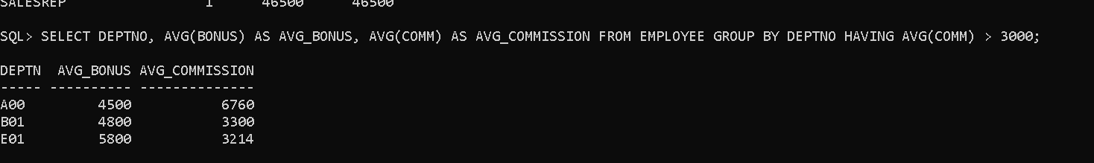

- Display the education level, employee count and average salary for education levels having an average salary greater than 40,000.
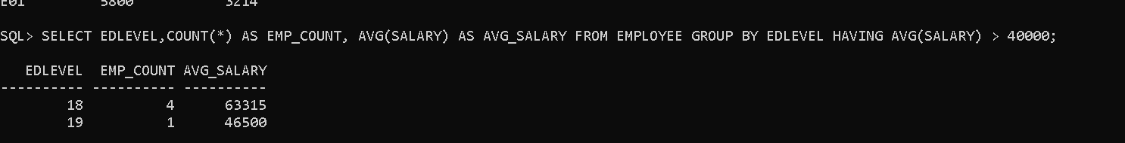

- Display the gender, employee count, average salary and total commission where the average salary exceeds 35,000.
- Display the department number, maximum salary, minimum salary and average salary for departments having at least 2 employees.
